SM – REDESIGN

TABLE OF CONTENTS – HOMEPAGE (pic #1)

1. HEADER:
1.1. LOGO
1.2. LOG IN FIELD

2. TOP MENU:
2.1. LINKOVI (LINKS)
2.2. DONIRAJTE (DONATE)
2.3. GALERIJA (GALLERIES)
2.4. MEDIJI O NAMA (MEDIA ABOUT US)
- AUDIOGALERIJE (AUDIO GALLERIES)
- VIDEOGALERIJE (VIDEO GALLERIES)
- NOVINSKI ČLANCI (PRESS CLIPPING)
2.5. O NAMA (ABOUT US)
2.6. BESPLATNA PRAVNA POMOĆ (FREE LEGAL AID)
2.7. KONTAKT (CONTACT)

3. MAIN MENU
3.1. SUDSKA PRAKSA (CASE LAW) – we are cutting this section!
3.2. SUDSKI VJEŠTACI (EXPERT WITNESSES)
3.3. TUMAČI (INTERPRETERS)
3.4. SUDOVI (COURTS)
3.5. DRŽAVNA ODVJETNIŠTVA (DISTRICT ATTORNEY'S OFFICE)
3.6. PRETRAŽIVAČ NADLEŽNOSTI (JURISDICTIONAL SEARCH)
3.7. WEB STEČAJ (WEB BANKRUPCY)
3.8. SUDSKE PRISTOJBE (COURT FEES)

4. HOMEPAGE BODY
4.1. NOVE STEČAJNE PONUDE
4.2. SEARCH BAR
4.3. GALERIJE
4.4. DONATORI

5. FOOTER
5.1. DONATORI (SPONZORI) CAROUSEL WITH LOGOS
5.2. ADDITIONAL INFO (TELEPHONE NUMBER, EMAIL ADDRESSES..)

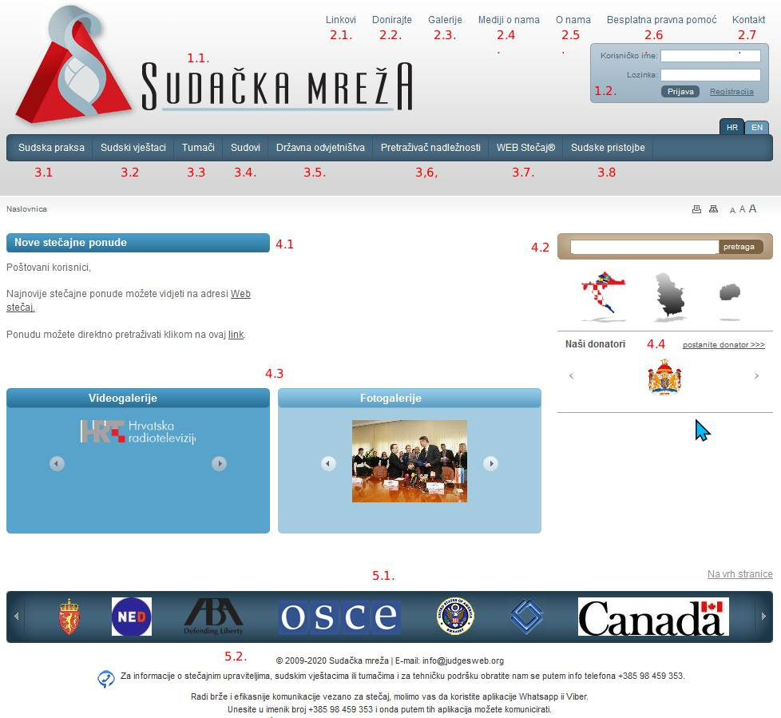
pic #1

2. TOP MENU:

2.1. LINKOVI (LINKS) – just a list of all useful links: http://www.sudacka-mreza.hr/linkovi.aspx

2.2. DONIRAJTE (DONATE) – a page with instructions for donations: http://www.sudacka-mreza.hr/sadrzaj.aspx?G1=donirajte

2.3. GALERIJA (GALLERIES) – a page with all photo galleries with short descriptions: http://www.sudacka-mreza.hr/galerije.aspx?Cat=31

2.4. MEDIJI O NAMA (MEDIA ABOUT US) – mentions from the media (audio, video and press):
- AUDIOGALERIJE (AUDIO GALLERIES) – audio mentions (mostly radio with short description and date): http://www.sudacka-mreza.hr/galerije.aspx?Cat=11
- VIDEOGALERIJE (VIDEO GALLERIES) – video mentions (mostly TV with short description and date): http://www.sudacka-mreza.hr/galerije.aspx?Cat=21
- NOVINSKI ČLANCI (PRESS CLIPPING) – press clipping from newspaper and web portals: http://www.sudacka-mreza.hr/popis-dokumenata.aspx?Cat=10

2.5. O NAMA (ABOUT US) – usual static page with „about us“ text: http://www.sudacka-mreza.hr/sadrzaj.aspx?G1=o-nama

2.6. BESPLATNA PRAVNA POMOĆ (FREE LEGAL AID) – static page with short info text: http://www.sudacka-mreza.hr/bpp.aspx

2.7. KONTAKT (CONTACT) – classic contact form with short instructions and these sections:
a) Ime i prezime (Your Name)
b) Vaš email (Your Email)
c) Predemet (Subject) - in redesigned version, I would rather leave the option for freely writing the subject, instead of choosing suggested subjects
d) Poruka (Message)
e) Pošalji gumb (Send button)
Current contact form is on this link: http://www.sudacka-mreza.hr/kontakt.aspx

3. MAIN MENU

3.1. SUDSKA PRAKSA (CASE LAW) – we are cutting this section!

3.2. SUDSKI VJEŠTACI (EXPERT WITNESSES) (pic #2) – Static page focused on expert witnesses with search bar: http://www.sudacka-mreza.hr/vjestaci.aspx

3.2.1. Opis sekcije (Description text)
3.2.2. Pretraga vještaka (Expert witnesses – search) – search bar with these search parameters:
a) Ime i prezime vještaka / Tvrtka / Adresa (Name and surname / Company / Address)
b) Grana djelatnosti (Branch of activities)
c) Podgrana djelatnosti (Sub branch of activities)
d) Županija (County)
e) Grad (City)
Additional search:
a) CV (Attached CV`s)
b) Priloženi radovi (Attached works)
c) Tvrtke (Company)

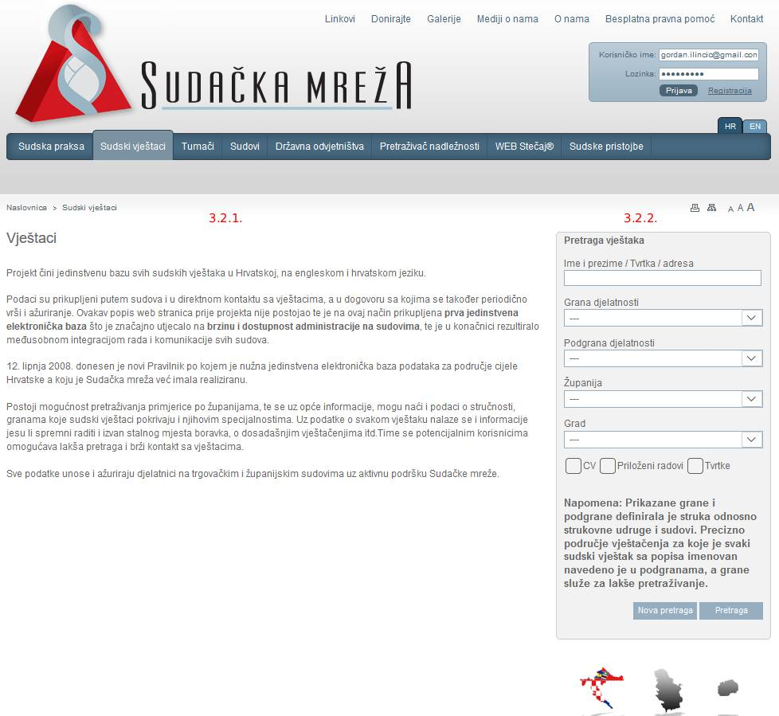
pic #2

3.3. TUMAČI (INTERPRETERS) (pic #3) - Static page focused on court interpreters with search bar: http://www.sudacka-mreza.hr/tumaci.aspx?Lng=hr

3.3.1. Opis sekcije (Description text)
3.3.2. Pretraga tumača (Court intrepeters - Search) – search bar with these search parameters:
a) Ime i prezime / naziv (Name and surname)
b) Strani jezik 1 (Foreign language 1)
c) Strani jezik 2 (Foreign language 2)
d) Županija (County)
e) Grad (City)
Additional search:
a) CV (Attached CV`s)
b) Priloženi radovi (Attached works)
c) Tvrtke (Company)

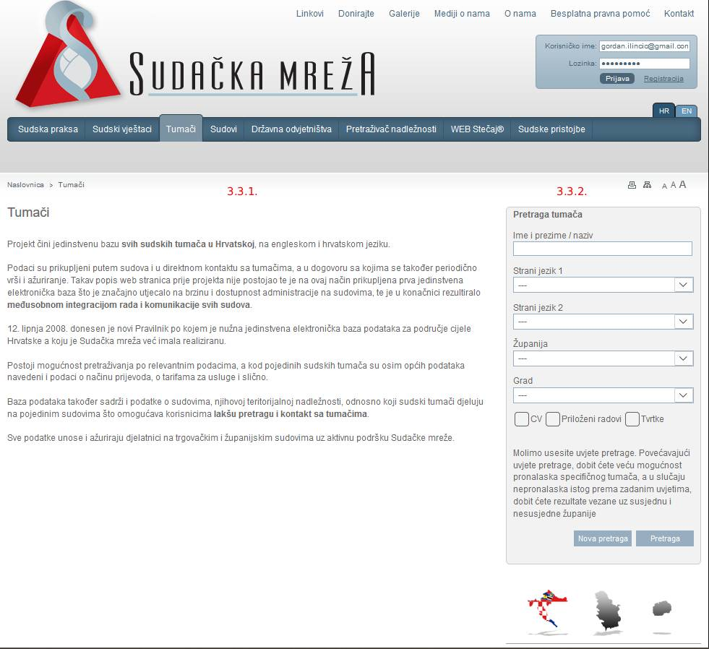
pic #3

3.4. SUDOVI (COURTS) (pic #4) - Static page focused on Courts with search bar: http://www.sudacka-mreza.hr/sudovi.aspx

3.4.1. Opis sekcije (Description text)
3.4.2. Pretraga Sudova (Court search) – search bar with these search parameters:
a) Naziv / adresa suda (Name / court address)
b) Vrsta suda (Court type)

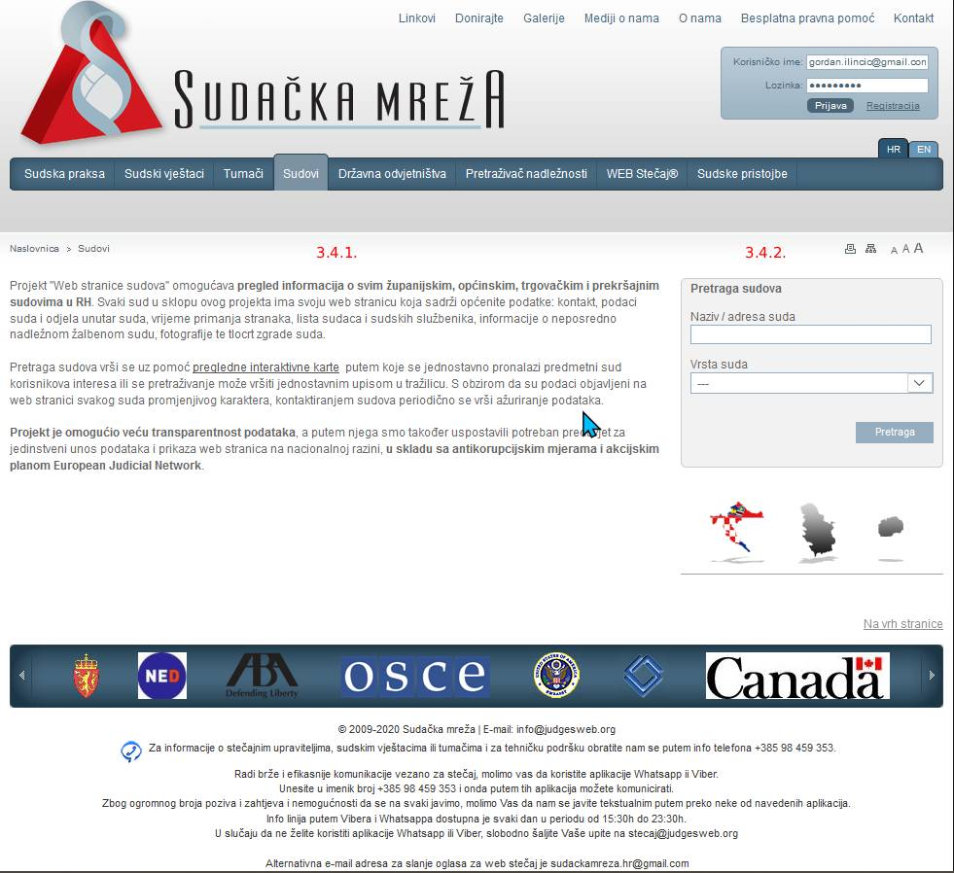
pic #4

3.5. DRŽAVNA ODVJETNIŠTVA (DISTRICT ATTORNEY'S OFFICE) (pic #5) - Static page focused on State Attorney's Offices with search bar: http://www.sudacka-mreza.hr/dorh.aspx

3.5.1. Opis sekcije (Description text)
3.5.2. Pretraga Državnih odvjetništava (State's Attorneys search) – search bar with these search parameters:
a) Naziv / adresa državnog odvjetništva (Name / address of state's attorney)
b) Vrsta odvjetništva (Type of state attorney)

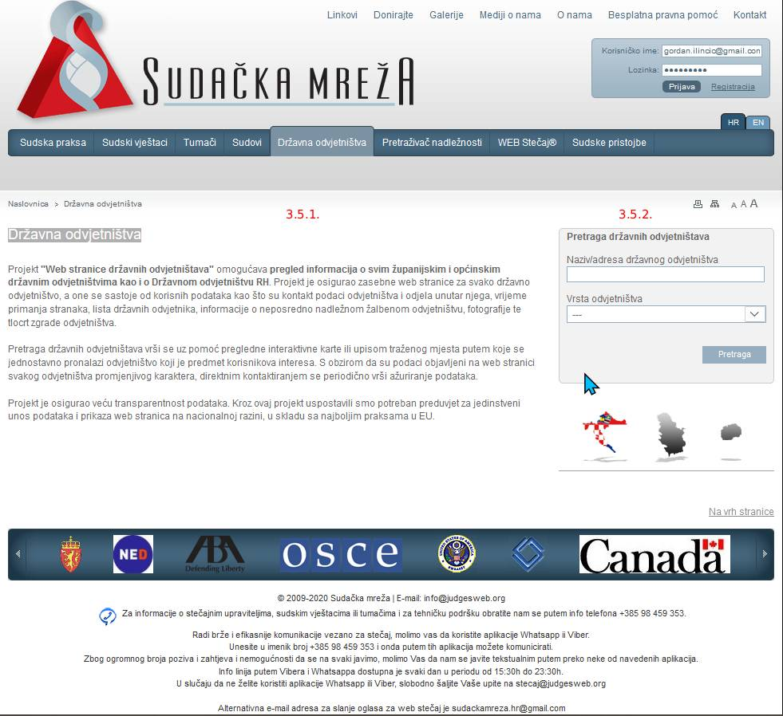
pic #5

3.6. PRETRAŽIVAČ NADLEŽNOSTI (JURISDICTIONAL SEARCH) (pic #6) - Static page focused on Jurisdiction Search with search bar: http://www.sudacka-mreza.hr/nadleznost.aspx

3.6.1. Opis sekcije (Description text) – maybe we could also add some kind of interactive map with all jurisdictional units?
3.6.2. Pretraga Nadležnosti (Jurisdictional search) – search bar with these search parameters:
a) Karta nadležnosti (Map of jurisdiction)
b) Mjesto (Place)
c) Ulica, naselje, pojam... (Street, settelment, term...)

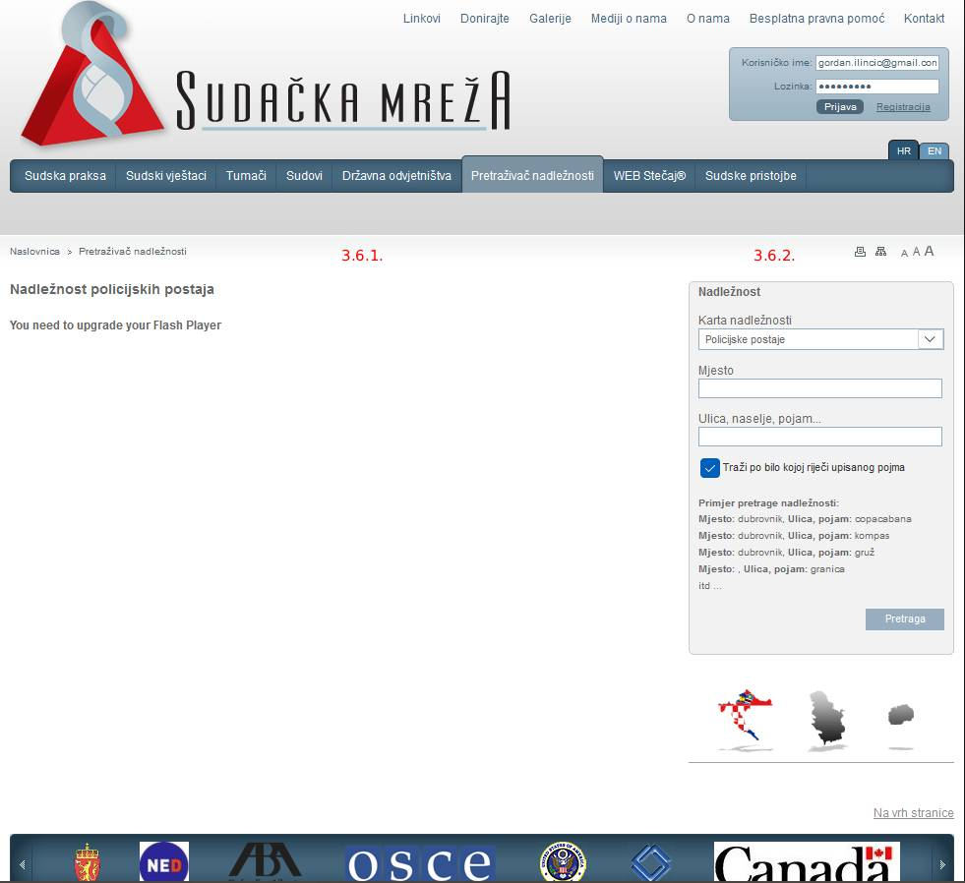
pic #6

3.7. WEB STEČAJ (WEB BANKRUPCY) (pic #7) - Static page focused on Web Bankrupcy with latest cases and search bar: http://www.sudacka-mreza.hr/stecaj-ponude.aspx?Lng=hr

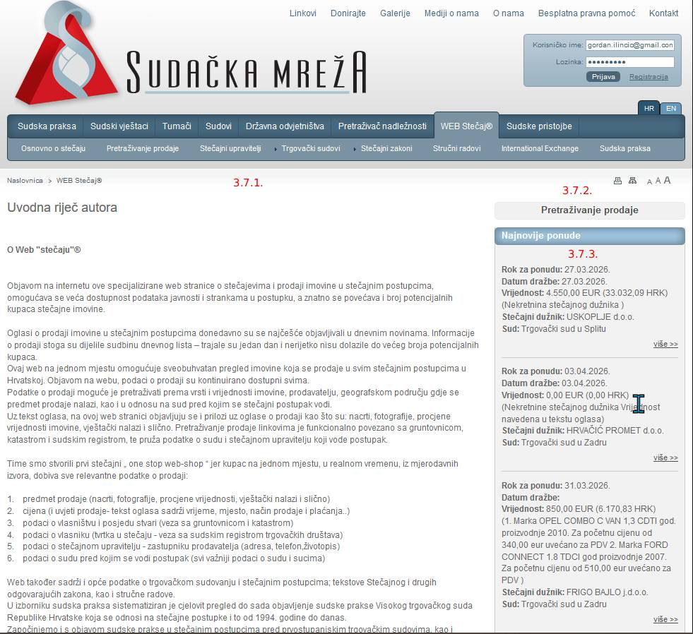
pic #7
3.7.1. Opis sekcije (Description text)
3.7.2. Pretraga Web stečajeva (Web Bankrupcy) – search bar with these search parameters (pic #8):
a) Pretraži u tekstu (Text search)
b) Sud (Court)
c) Kategorija imovine - nekretnine, pokretnine, prava (Assets category - Immovable, Movable, Rights)
d) vrsta imovine (Type of Assets)
e) stečajni dužnik (Bankruptcy debtor)
f) Stečajni upravitelj (Bankruptcy Trustee)
g) Status (Status)
3.7.3. List of 10 latest web bankrupcy cases

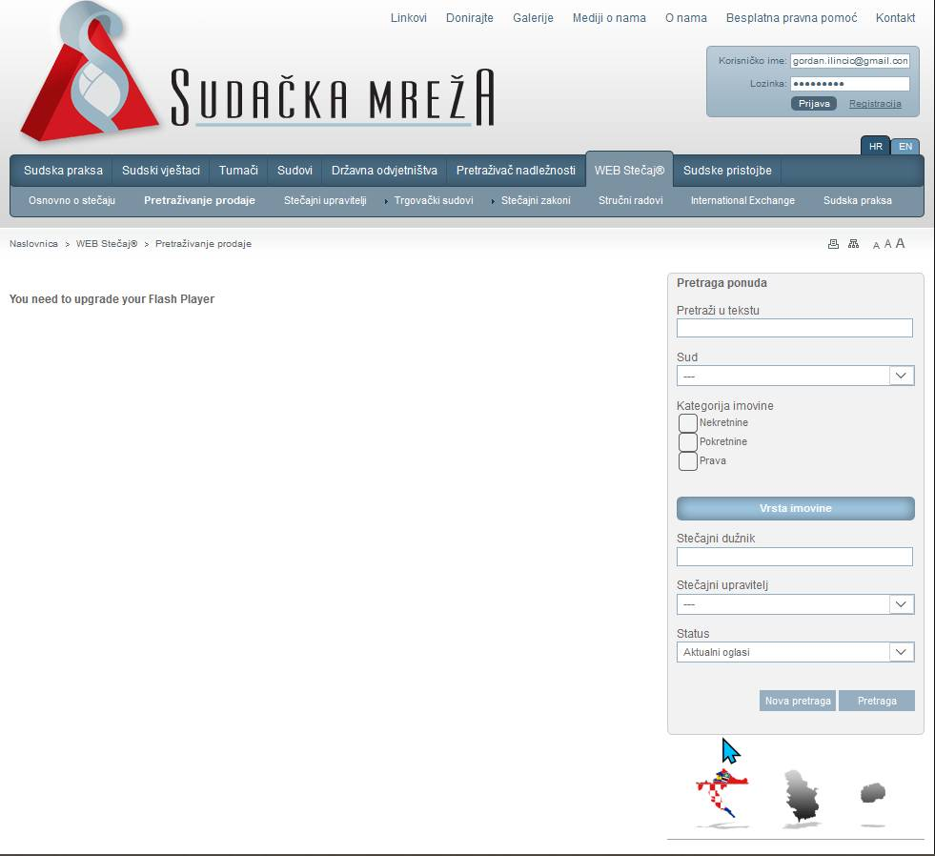
pic #8
3.7. WEB STEČAJ (WEB BANKRUPCY) SUBSECTIONS (pic #9) – link: http://www.sudacka-mreza.hr/web-stecaj.aspx

3.7.a. Osnovno o stečaju (Overview of CBS)
3.7.b. Pretraživanje prodaje (Sale of assets)
3.7.c. Stečajni upravitelji (Bankruptcy Trustees)
3.7.d. Trgovački sudovi (Commercial Courts)
3.7.e. Stečajni zakoni (Bankruptcy Laws)
3.7.f. Stručni radovi (Professional Work)
3.7.g. International Exchange (International Exchange)
3.7.h. Sudska praksa (Judical Practice)

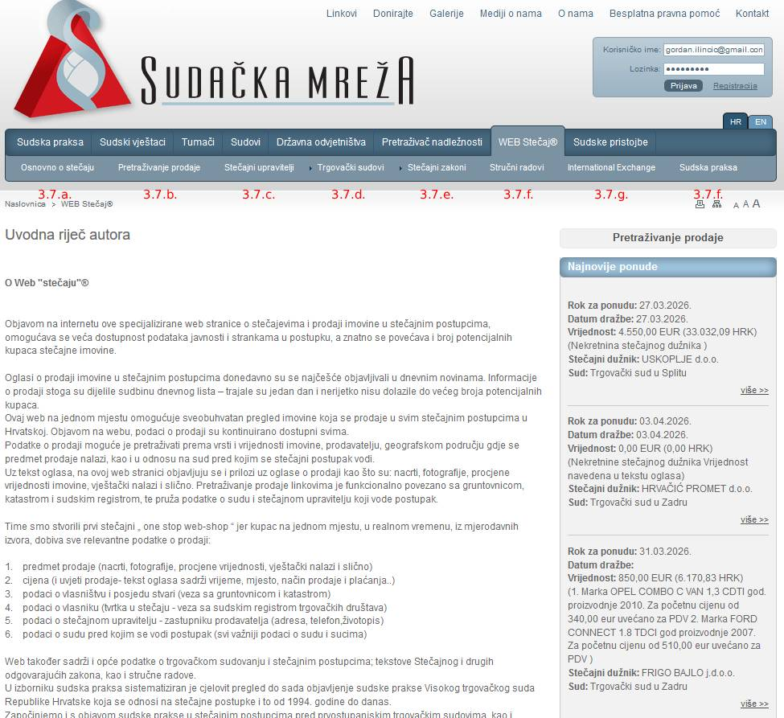
pic #9
3.7.a. Osnovno o stečaju (Overview of CBS) (pic #10) – link: http://www.sudacka-mreza.hr/web-stecaj.aspx?G1=&G2=osnovno-ste%C4%8Daj

3.7.a.1. Opis sekcije (Description text)
3.7.a.2. Pretraga Web stečajeva (Web Bankruptcy) – search bar (same search for Web Bakruptcy)
3.7.a.3. List of 10 latest web bankruptcy cases

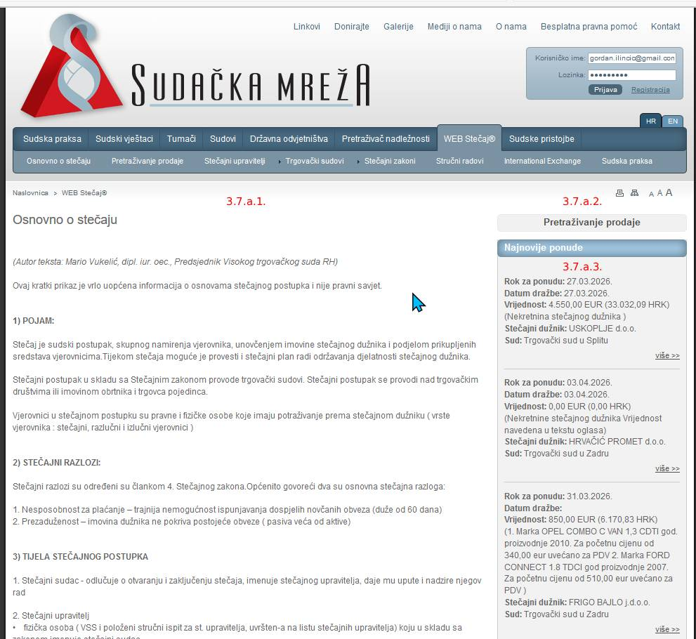
pic #10

3.7.b. Pretraživanje prodaje (Sale of assets) (pic #11) – link: http://www.sudacka-mreza.hr/stecaj-ponude.aspx

3.7.b.1. Sekcija za rezultate pretrage (Section with sales listed through search)
3.7.a.2. Pretraga Web stečajeva (Web Bankruptcy) – search bar (same search for Web Bakruptcy)
3.7.a.3. List of 10 latest web bankruptcy cases

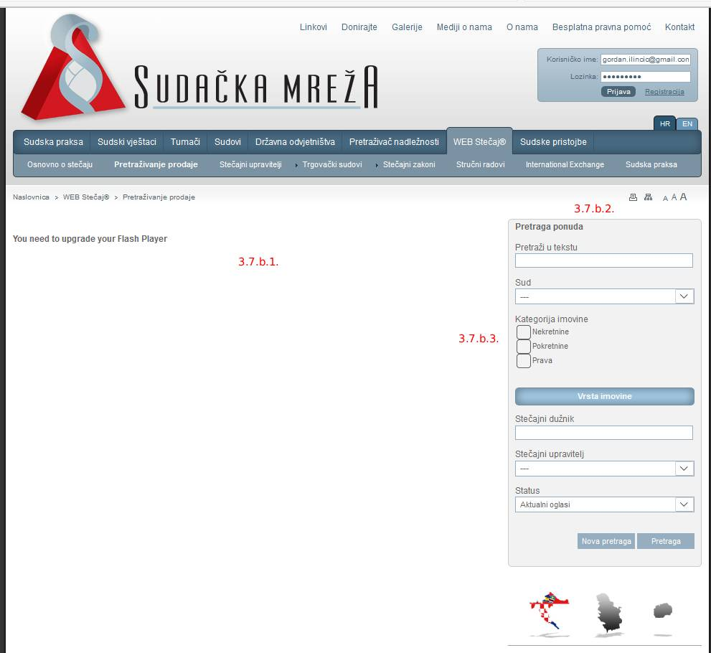
pic #11

3.7.c. Stečajni upravitelji (Bankruptcy Trustees) (pic #12) – link: http://www.sudacka-mreza.hr/stecaj-upravitelji.aspx?Lng=hr

3.7.c.1. Opis sekcije (Description text)
3.7.c.2. Pretraga stečajnih upravitelja (Bankruptcy Trustees search) – search bar with these search parameters:
a) Ime i prezime upravitelja (Name and surname of the trustee)
b) Sud (Court)

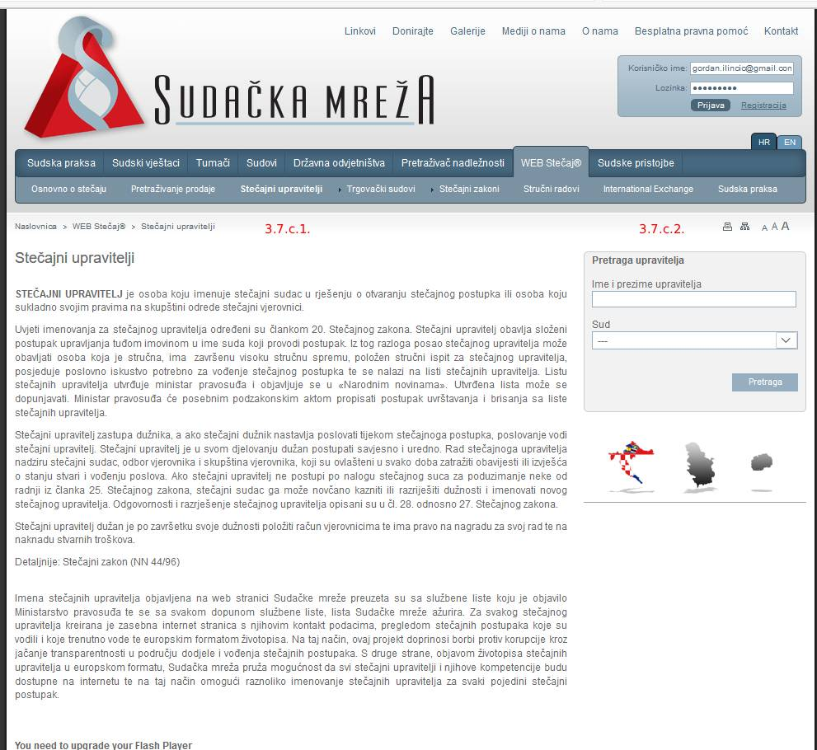
pic #12
3.7.d. Trgovački sudovi (Commercial Courts) (pic #13) - link: http://www.sudacka-mreza.hr/web-stecaj.aspx?G1=&G2=o-trgovackom-sudovanju#

3.7.d.1. Opis sekcije (Description text)
3.7.d.2. Pretraga Web stečajeva (Web Bankruptcy) – search bar (same search for Web Bakruptcy)
3.7.d.3. List of 10 latest web bankruptcy cases
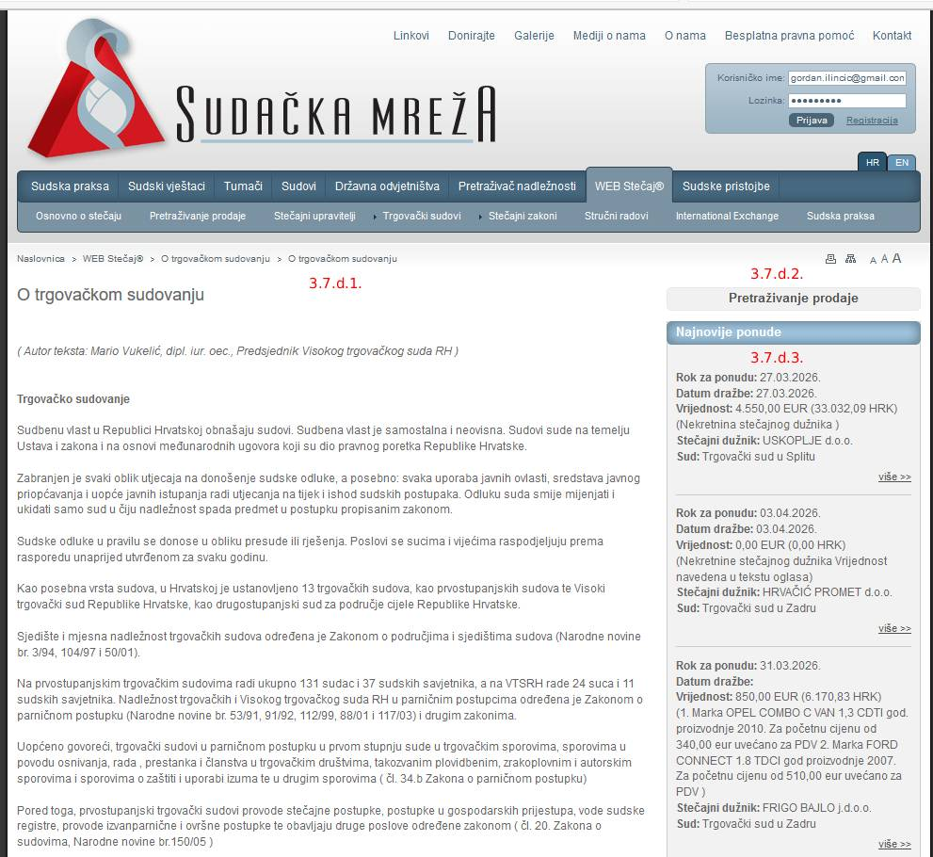
pic #13
3.7.e. Stečajni zakoni (Bankruptcy Laws) (pic #14) - link: http://www.sudacka-mreza.hr/web-stecaj.aspx

This section should be switched to static page with the list of all the laws sorted (either alphabeticaly or chronologicaly)

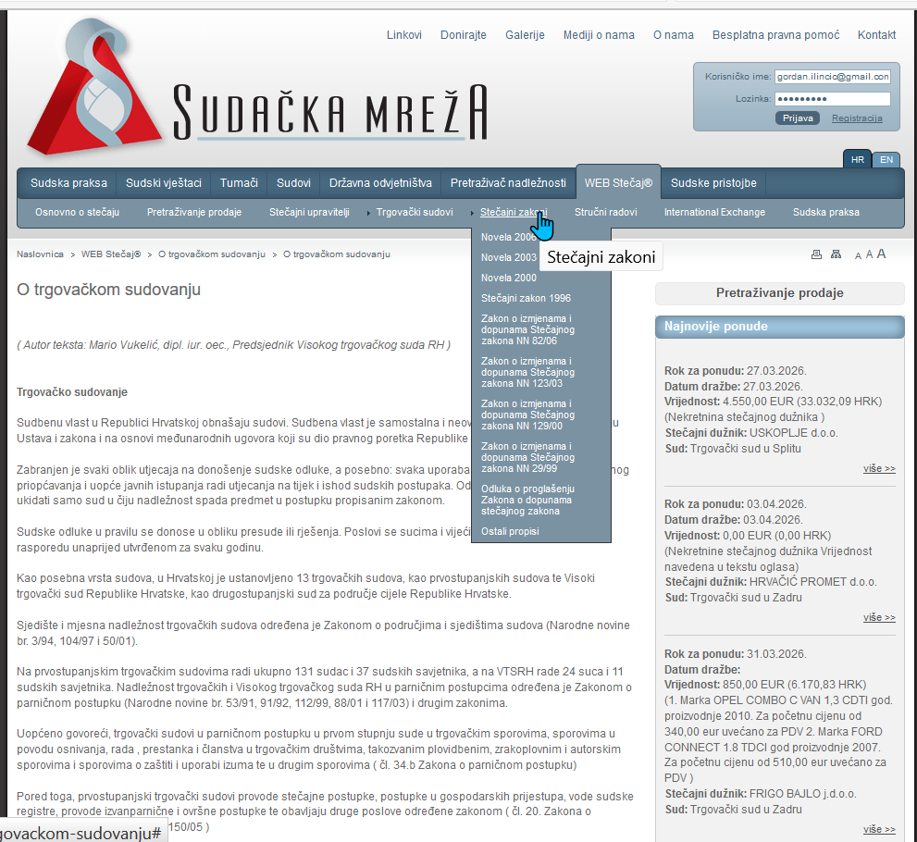
pic #14
3.7.f. Stručni radovi (Professional Work) (pic #15) - link: http://www.sudacka-mreza.hr/sr.aspx?Type=1

3.7.f.1. Lista stručnih radova s opisima i linkovima (List of Professional Works with description and links)
3.7.f.2. Pretraga Web stečajeva (Web Bankruptcy) – search bar (same search for Web Bakruptcy)
3.7.f.3. List of 10 latest web bankruptcy cases

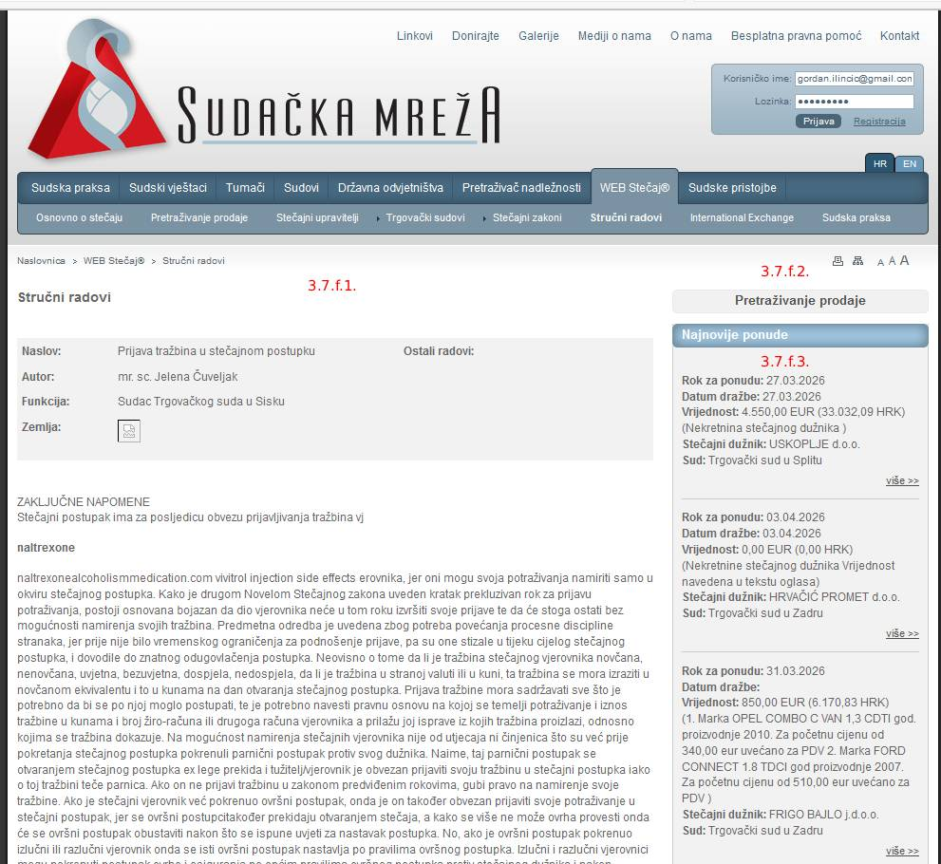
pic #15
3.7.g. International Exchange (International Exchange) (pic #16) - link: http://www.sudacka-mreza.hr/sr.aspx?Type=2

3.7.g.1. Lista radova s međunarodne razmjene s opisima i linkovima (International Exchange Works with description and links)
3.7.g.2. Pretraga Web stečajeva (Web Bankruptcy) – search bar (same search for Web Bakruptcy)
3.7.g.3. List of 10 latest web bankruptcy cases

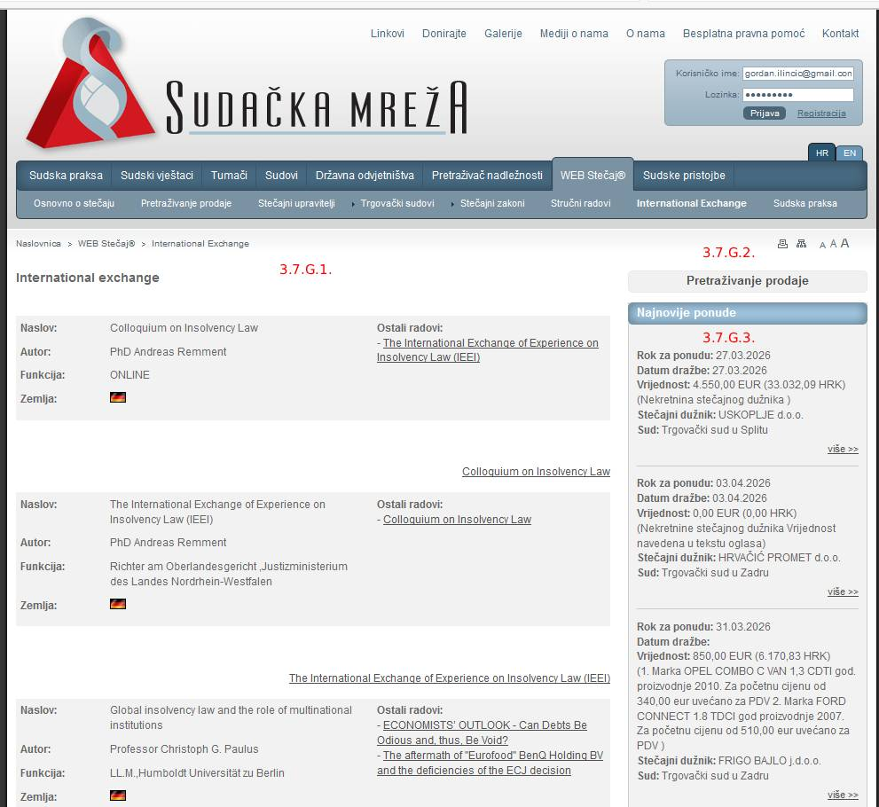
pic #16
3.7.h. Sudska praksa (Judical Practice) (pic #17) - link: http://www.sudacka-mreza.hr/stecaj-sudskapraksa.aspx
3.7.h.1. Opis sekcije (Description text)
3.7.h.2. Pretraga Sudske prakse (Judical Practice search) – search bar (same search for Judical Practice) with these parameters:
a) Kriterij pretrage (Search Criteria)
b) Zbirka (Collection)
c) Vrsta kazala (type of registry)

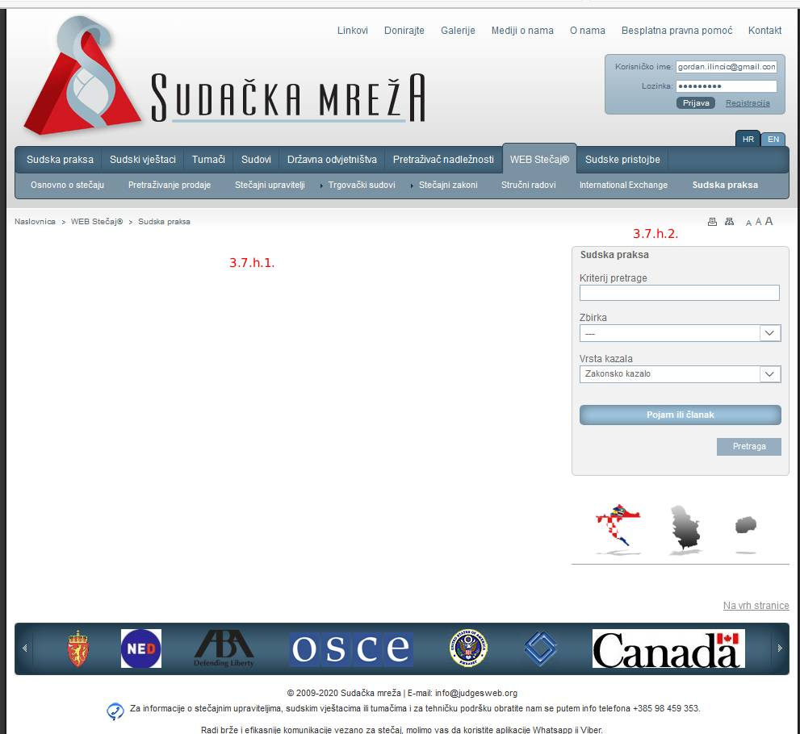
pic #17
3.8. SUDSKE PRISTOJBE (COURT FEES) (pic #18) - link: http://www.sudacka-mreza.hr/pristojbe.aspx?Lng=hr

3.8.1. Opis sekcije (Description text)
3.8.2. Instrukcije (Instructions)
3.8.3. Kalkulator za sudske pristojbe (Calculator for Court Fees) - simple app that calculates the fees with these parameters:
a) Vrsta postupka (Type of proceeding)
b) Vrsta radnje (Type of legal action)
c) Radnja (Legal action)
d) Pristojbe od... (Fee from...)
e) Vrijednost spora (Case value)
f) Izračunaj gumb (Calculate button)
g) Tarifni broj (Fee number)
h) Iznos pristojbe (Fee amount)

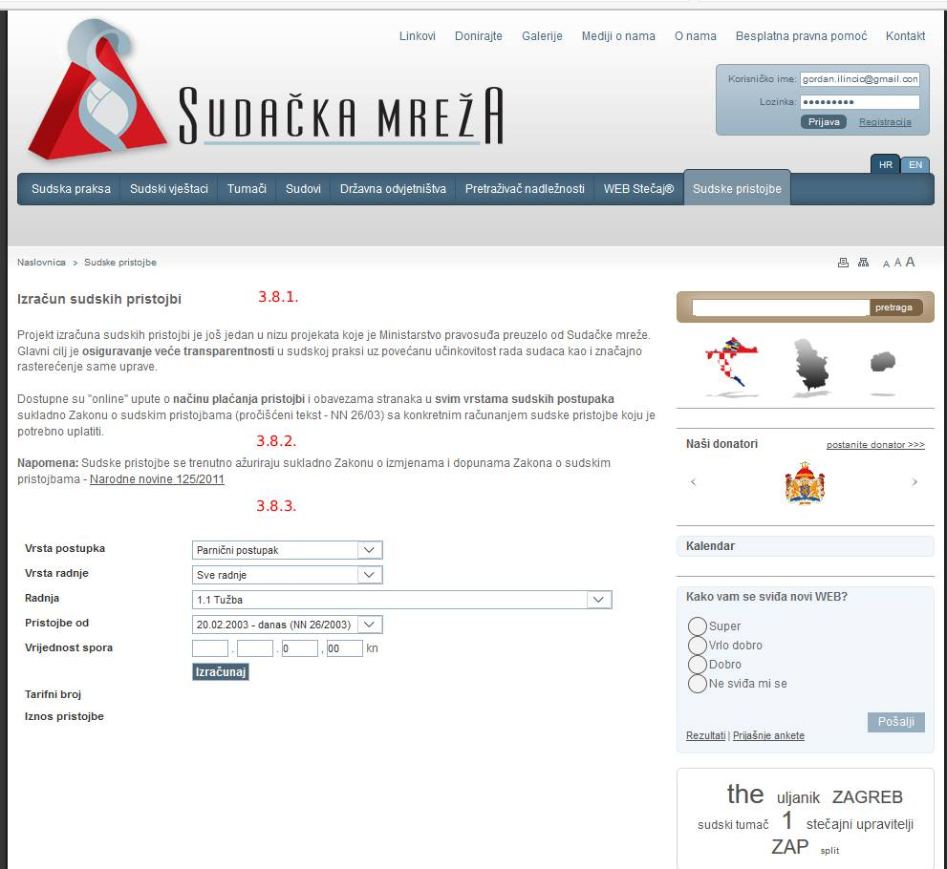
pic #18
Additional Suggestions:
- I think it would be cool if we could add some chatbot for any inquiries about Web Bankruptcy, Expert Witnesses, Interpreters or even any other info from Judical Practice
- Some links and pages from the Top Menu (such as Useful links, Donate...) can be placed maybe in additional footer menu or in the form of the banner placed somewhere in the body of the homepage?

